Ethnicity

Where are ethnicities distributed?

Ethnicity - the identity of a group of people who share the cultural traditions of a particular homeland or hearth. E.g. Britain contains three different ethic groups; the Welsh, English and Scottish.

Race - the identity of a group of people who share a biological ancestor.

Race relates to a person's appearance - chiefly the color of their skin. It is determined biologically, with genetic traits such as skin color, eye color, hair color, etc. Ethnicity, on the other hand, relates to cultural factors such as nationality, culture, ancestry, language and beliefs. For example, take the Caucasian race. The physical characteristics of Caucasians were described by M. A. MacConaill, as being "light skin and eyes, narrow noses, and thin lips. Their hair is usually straight or wavy". However, there are many ethnicities within the Caucasian race e.g. Irish, Welsh, German, French, Slovak, etc. What differentiates these ethnic groups from each other is their country of origin, language they speak, cultural heritage and traditions, beliefs and rituals.

The most common ethnicities within the U.S. are African Americans and Hispanics/Latinos, about 13% each. Others include Asian American (4%) and American Indian (1%). The fourteen races w/in the U.S., as decided by the Census, are: white, black-African American-Negro, American Indian-Alaska Native, Asian Indian, Chinese, Filipino, Japanese, Korean, Vietnamese, Native Hawaiian, Guamanian-Chamorro, Samoan, other Pacific islander, and lastly, other race.

Within a country, clustering of ethnicities may occur on a regional scale, or within particular neighborhoods of cities.

Regional:

-In the U.S., African Americans are clustered in the south eastern United States., Hispanics in the south west, Asians in the west, and Native Americans in the south west and Great Plains.

Within cities:

African Americans are highly clustered within cities in the USA, greater than 50% of blacks live within cities. In Detroit, A-A comprise 80% of the pop, but only one-fourteenth the pop of the rest of Michigan.

The distribution of Hispanics in northern cities is similar to that of African Americans, for instance NYC is ¼ Hispanic, but only 1/16th the rest of New York State.

The clustering of ethnicities is especially visible on the neighborhood level. Such as in Chicago where many of the immigrants from Southern and Eastern Europe tended to
chain migrate to specific city blocks in such density that certain areas of town became known for a specific ethnicity. Think of Little Italy in New York, Chinatown in San Franciso and Korea Town in L.A.

However, more recently, descendant’s immigrants are more likely to retain their ethnic identity through religion, food, and other cultural traditions rather than through location of residence.

The current clustering of African Americans within the U.S. results from three major migration flows:
- Immigration from Africa in the 18th century (slave trade)
- Immigration from the South to northern cities during first ½ of 20th century.
- Immigration from inner-city ghettos to other urban neighborhoods in the second ½ of the 20th century.

‘Blockbusting’ and ‘white flight’

“White flight” is the rapid fleeing of whites from the cities as black families emigrate out of the ghettos, or as the ghetto expands. It was encouraged by blockbusting.
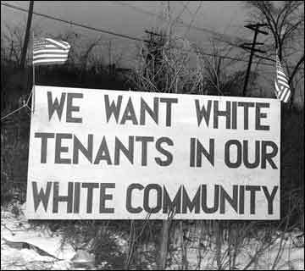
Blockbusting - the real estate practice of scaring whites into selling their homes at low prices by telling them that blacks would soon be moving in and causing property values to fall. The real estate agents then turned around and sold the homes at extremely high prices to blacks that were emigrating from the inner city.

Apartheid in South Africa

In South Aftica there used to be apartheid laws which physically separated the Whites and Blacks. The Whites lived in areas which provided a good standard of living where as the Blacks lived in poverty. The apartheid laws were repealed in 1991 in South Africa, but many years will be needed to erase the legacy of such racist policies.

Scale and Identity

Ethnic identity is greatly affected by scale and place. In America many people will group people from India and Pakistan under the term ‘South Asians’. However, India and Pakistan have a history on animosity between each other and the people from there would identify themselves as either Indian or Pakistani.

The difference between racial and ethnic conflicts

A conflict is known as an ethnic conflict when a ‘racial’ distinction cannot easily be made. For example, using physical appearance and skin colour, cannot distinqush the different ‘ethnic groups’ in many conflicts around the world. For examples, adversaries in the former Yugoslavia or Rwanda – they are the same RACE but have different ETHNIC backgrounds.
Why do ethnicities clash?

Often the cause of violence is when different ethnicities compete to rule the same region or nationality. This has been especially common in sub-Saharan Africa, where the superimposed boundaries of the Europeans colonies poorly coincide with the thousands of ethnicities. The Horn of Africa has been the site of many ethnic disturbances: Ethiopia and Eritrea, Sudan, Somalia, etc.
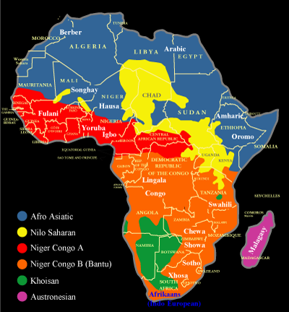
The other main source of ethnic violence occurs when ethnicities are divided among more than one state such as in South Asia where the British divided their former colony into Pakistan and India. (East Pakistan became Bangladesh after 1971) As a result of the partition, millions of Hindus had to migrate from the Pakistans, and Muslims had to migrate from India. During the course of the migrations, many adherents were killed by members of the opposite religion. Also, controversy continues in the northern area of Kashmir over the proper border. Similar unrest is present on the island of Sri Lanka, betwixt the Tamil Hindus and the Sinhalese Buddhists.

What is ethnic cleansing?

Ethnic cleansing is the process in which a more powerful ethnic group forcible removes a less powerful one in order to create an ethnically homogeneous region. Probably the preeminent example is WWII in which millions of Jews, gypsies, and other ethnicities were forcibly moved to concentration camps, where most were exterminated.

When Yugoslavia was one country, encompassing multiple ethnicities, dissent was kept under control. However, once Yugoslavia broke up into six republics, the boundaries did not align with the boundaries of the five largest nationalities, and ethnicities fought to redefine the boundaries. In some cases, as in Bosnia and Kosovo, ethnic cleansing was used to strengthen certain nationalities’ cases for autonomy. As a result, millions of ethnicities were forcibly removed from their homes, and marched elsewhere, or simply killed. Similar ethnic cleansing occurs in Central Africa betwixt the Hutus and Tutsis.

The term ‘Balkanized’ is used to describe a small geographic area that could not successfully be organized onto one or more stable states because it was inhabited by many ethnicities with complex, long-standing antagonisms toward each other. (Yugoslavia was located in the Balkan region).

‘Balkanization’ is the process by which a state breaks down due to conflicts among its ethnicities. We will study these processes in more detail in our next unit called ‘Political Geography’.

