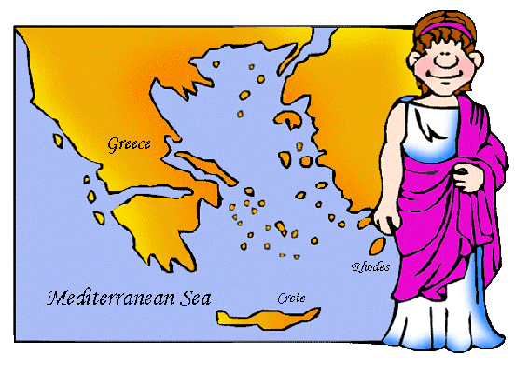
Task: Read through the following and highlight aspects of the geography of Greece that would be considered a drawback and aspects that would be considered a drawback. Then stick it in your book.
Compared with Mesopotamia and Egypt, Greece is a small peninsula. It is made up of small plains and river valleys surrounded by high mountains. The mountains influenced Greek history, because they separated Greeks from each other. This caused different Greek communities to develop their own ways of life. The small size of these communities encouraged people to be involved in politics. But the rivalries between the communities led to constant warfare.

The seas also influenced Greek history. Greece has a long sea coast with many harbors, so the Greeks became seafarers. Greeks also lived on many islands off the Greek mainland. Greece is a peninsula, which means that it is surrounded on three sides by water. Greece has a lot of smaller peninsulas sticking out from it, which means Greece enjoys many natural harbors. Greece is also covered with mountains. They are not huge mountains but if you are trying to go from place to place in Greece, you'll find the mountains a bit of a hindrance. Due to its mountainous nature arable land was scarce leading to need to expand and conquer other areas to set up colonies once it population began to increase. This required them to be excellent sailors and so they excelled in boat construction. Close proximity to the sea meant and the Mediterranean climate meant that Greeks ate a lot of fish, olive oil and bread. The soil was not very fertile along the coastline. The ancient Greeks used systems of irrigation and crop rotation to help solve that problem.
All over Greece, the people grew olives, grapes, and figs. They kept goats, for milk and cheese. In the plains, where the soil was more rich, they also grew wheat to make bread. Fish, seafood, and home-made wine were very popular food .
Four thousand years ago, it was very difficult to get from place to place in ancient Greece by walking. But it was easy to get from place to place in Greece by boat. In the ancient world that grew up around the Mediterranean Sea, the Greeks became known as great sailors. They sailed about the Mediterranean, setting up colonies and outposts where they could. The mountainous land also meant that it was difficult to invade Greek lands. The Balkan Mountains in the north and the Mediterranean Sea form barriers that made it difficult for outsider to attack.

Task: Complete the following table in your notebook using the above and p.106 “The Aegean Area”
The Geography of Ancient Greece
Advantages | Drawbacks

