Thomas Malthus published An Essay on the Principle of Population in 1798
Predicted that the global population would one day expand to the point where it could not produce enough food to feed everyone
He predicted this would happen before 1900
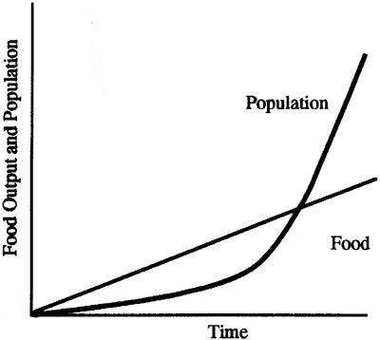
Why this idea?
- UK was engaged in the Industrial Revolution and people were being born at a high rate
- Britain was moving from stage two to stage three on the DTM
  - Malthus saw massive migration to the cities and enormous population growth
- Malthus saw that food production grew over time, but slowly linear
  - Meanwhile, human population grows exponentially
What Happened, Instead?
- Agricultural technology was going to boost food production in multiples in the 1800s
  - By 1900, inventions such as the internal combustion engine, artificial fertilizers, pesticides, irrigation pumps, the tin can, and the refrigerator would increase food production/storage
- A large volume of food would be added to global production and supply
  - Food production has continued to stay ahead of population growth
Genetics
- In the early 1800s, Gregor Mendel was the first to research/write about genes and plant reproduction
  - Genetics did not make an impact on global food production until the 1950s, and genetically modified food did not enter the markets until the 1980s
- When asked why Malthus was wrong, do not mention genetics, since that has only affected food production in the recent years
Neo-Malthusians
Neo-Malthusians are more recent theorists who warn that a Malthusian catastrophe could still occur. You might think that things don’t seem too bad now and that within a generation or two, the global population will level off. Won’t we just come up with new technologies to meet future food demands?
- Three Important Points are made by Neo-Malthusians:
- Sustainability- When the world does reach 10 billion people, there may be problems keeping up with food demand over the long-term
  - Many agricultural regions already have significant ecological problems
    - Soil erosion and soil nutrient loss and in arid regions, depletion of irrigation sources and soil salinization
- Increasing Per Capita Demand- The amount of food consumed per person is increasing
  - First World consumers consume around eight times more the amount of food and resources that a Third World consumer consumes
    - As Third World countries develop, more food and resources are consumed
- Natural Resource Depletion- Theorists like Paul Ehrlich have also warned about our over-consumption of other resources such as timber, minerals, energy, and other nonrenewable resources
  - We need to conserve and look for alternatives so that we can stretch out supplies over time

Name of Model:

Person who developed the model/theory: (short bio)
Premise: (What is the model supposed to explain?)
Function: (How or when is the model used?)
Illustration: (Draw the model or symbols to demonstrate the key ideas)

Strengths of this model:

Weaknesses of this model:

Effectiveness of the model for predicting geographic outcomes. Does it still apply today? When or where and with what modifications?

