Polish Migration to the United Kingdom
1) The Treaty of Rome allows any European Union citizen to move, settle and work in a fellow European Union country. | 2) The UK was only one of three EU countries to allow unlimited access to its labour market to the ‘A8’ countries, as long as workers registered. | 3) The agriculture sector has faced a shortage of workers; British workers have not been keen to take up these positions. | 4) A8 countries became part of the European Union in 2004.
5) Right-wing political parties, such as the BNP have sort to exploit concerns over migration. | 6) 63% of Polish migrants were aged 25-34, 40% had a university degree. | 7) The average income in Poland was $12,500 a year. | 8) A House of Lords report suggested that Eastern European migration has pushed wages down, and created competition, but this disadvantaged some low skilled British workers.
9) The A8 countries had a standard of living which was 40% of the European Union average. | 10) In 2007, there were 607,000 job vacancies for skilled and semi-skilled labour. | 11) Only 7,000 registered workers have applied for income support. | 12) It is estimated 500,000 workers migrated to the UK after the A8 joined the EU, most were Polish.
13) There are many established Polish communities in the United Kingdom, many originate from the Second World War. | 14) 0.5-1% of economic output was attributed to Eastern European workers in 2006. | 15) Polish workers were known for having a strong work ethic. | 16) If registered, and working, migrants can claim certain benefits such as housing benefit and tax credits- under the Worker Registration Scheme.
17) The Office for National Statistics suggested that since 1997, 1.67 million jobs were created in the British economy, but 98% were filled by migrants. | 18) Average wage in Poland was £150 pounds a month. | 19) The largest proportion of Polish migrants, 33%, were employed in administration. | 20) Tesco advertised in Poland for 140 lorry drivers due to shortages.
21) In some areas strain has been put on primary schools places, teachers have also had to cope with classes with students who speak English as a second language. | 22) Polish migrants brought 36,000 dependents, 26,000 child benefit applications have been approved. | 23) 62% of all Eastern European migrants were from Poland. | 24) In 2004 the Public Policy Research Unit stated that Polish migration had little effect on unemployment within the British Population.
25) Supermarkets and shops responded by adding Polish brands to their ranges. | 26) The average income in the UK was $30,000 a year. | 27) 2007 official figures showed that 431,000 Polish migrants were registered to work in the UK. | 28) Ryanair runs cheap flights to and from Poland.
29) 50% of the registered workers tend to be the young looking for part-time summer work in agriculture. | 30) Migrant workers must have been in full time employment for 12 months, to claim Job Seekers Allowance under the Worker Registration Scheme. | 31) Before the economic crisis the Pound was strong against the Zloyt, every pound could be exchanged for 7 Zloyts. (This has decreased to 4.7) | 32) 2007- 42 Poles reported racially motivated attacks to the police. Polish community leaders are concerned about an increase in hate crimes.
33) The minimum wage in the UK is £5.93 an hour. | 34) The influx of migrants has raised rents, a House of Lords report has suggested if such migrations continue it could raise house prices by 10% over the next 20 years. | 35) Councils and businesses have had to employ translators and print literature to cater for new migrants. | 36) Poland had the second highest employment rate in the European Union- 18.5%- 2005. 40% in some rural areas.
37) Over 500 Polish doctors have migrated to the UK. | 38) The construction industry has particularly benefit from Polish migration, there has been a shortage of bricklayers, plumbers etc. | 39) In 2007 the employment rate in the UK was 5.1% . | 40) The benefit of A8 migrants to the UK economy has been estimated at £2.8 billion a year.
41) The UK has an aging population and needs younger workers. | 42) 10% of Polish migrants were employed by the National Health Service. | 43) Migration is set to increase the UK’s population to 65 million by 2016. | 44) Over half of all Eastern European migrants return home.
45) The recent economic crisis has seen a number of Polish migrants return home. | 46) Rowntree Foundation reported its concerns about employers exploiting Polish workers. | 47) In 2007 it was estimated that Polish workers sent home £1 billion pounds, which could have been spent in the UK economy. | 48) Inner city doctors have been concerned by the influx of migrants; these have put additional pressure of services.
49) 10% of Polish migrants have located in rural areas, supporting local services which would have declined otherwise. | 50) Polish migrants have increased Church attendance, which was steadily declining. | 51) Migrants have tended to locate in urban areas, closer to employment opportunities and transport- but this has caused friction. | 52) Numbers of economic migrants have lead to pressure on the UK government to implement tougher immigrant Policies- but this can’t be enforced for EU migrants.
53) There has been an increase in the number of Polish migrants sleeping rough on the streets and in Parks, unable to claim benefits when they are out of work. 400 alone have been reported in London. | 54) To reduce their living costs migrants have shared bedrooms within rented houses, mostly young males, residents have complained about noise and drunkenness. | 55) Working migrants have to pay National Insurance and Council Tax; therefore they contribute to local services. | 56) Migrating offers the opportunity for Polish graduates to pay off debts and save money that can be used to purchase homes.

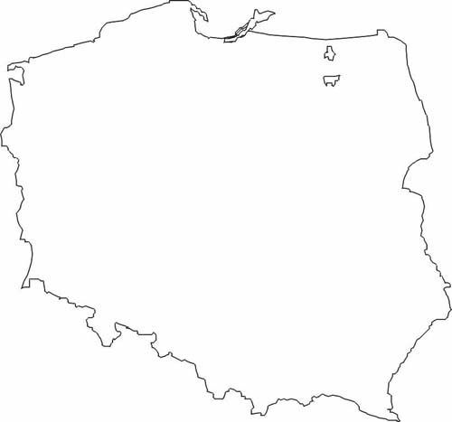
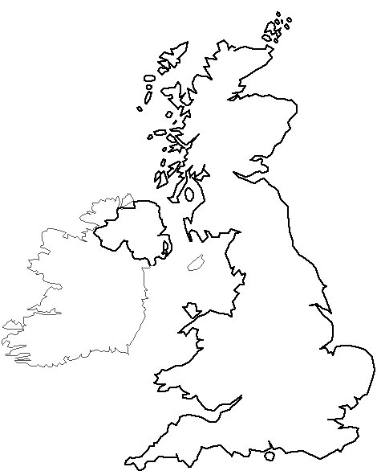
Polish Migration to the UK
PUSH FACTORS
PULL FACTORS
Evaluate the positive and negative impacts of international migration using one case study of a country within the European Union:
-numbers migrating, their origins and destination;
-impacts on services and the economy.

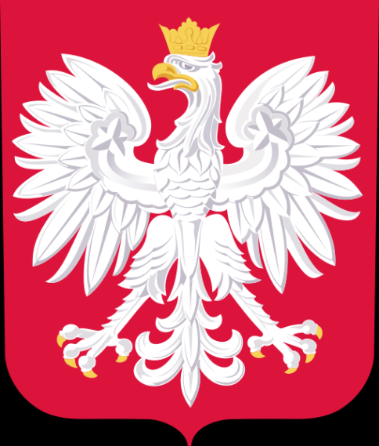

IMPACTS ON THE UK
ECONOMIC
SOCIAL

