Just as in product markets, there may be market failures in labour markets. Workers may be exploited by powerful employers who may put profit before safety; powerful trade unions may disrupt production and restrict labour supply to force employers to raise the wages of their members. As a result, governments in mixed economies may intervene in labour markets to achieve social and economic objectives. One such example is the introduction of the minimum wage laws in many countries.
ADVANTAGES OF THE MINIMUM WAGE
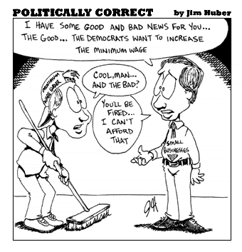
- Fair for workers to be paid a minimum wage.
- Helps low earners gain a higher standard of living
- Extra disposable income should lead to extra spending in the economy
- Helps increase the gap between wages for low earners and unemployment benefit
- May help reduce unemployment
DISADVANTAGES OF THE MINIMUM WAGE
- Increases the cost to businesses
- Businesses may increase their prices (cost push inflation)
- Businesses may be unable to afford to employ as many workers
- Could cause unemployment
- Other workers may now ask for a pay rise
- Doesn’t help the unemployed who don’t receive a wage
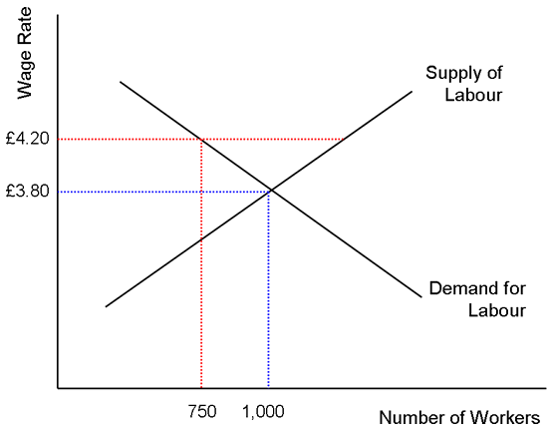
The government has raised the minimum
wage rate from 3.80 to 4.20 per hour

- Why has this created an excess supply
of workers?
____________________________________
____________________________________

- Under ‘normal market conditions what would
likely happen to the wage rate?
____________________________________
____________________________________
____________________________________

In the diagram above, £3.80 is the free market equilibrium wage, supply is equal to demand. At this point 1000 people are employed. Imagine that a minimum wage is imposed at £4.20. Some businesses can’t afford their wage bill and reduce their workforce. Now only 750 workers are employed. 250 have become unemployed. What would happen if the minimum wage were to increase by a further 50p? What would happen if it were to drop to 3.30?
