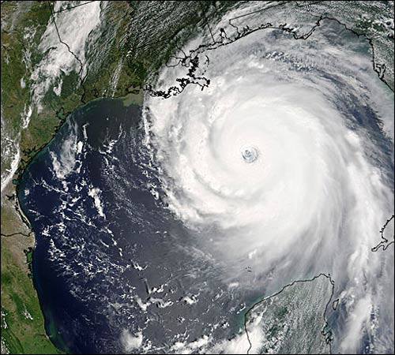

**Tasks.**

1. On map **one** and using an Oxford Atlas, *shade* the **United Kingdom** and the **United States**.

On the map of the United States, *shade the states* of **Louisiana**, **Mississippi** and **Alabama**.

Make sure you label *each of the shaded areas on your map*. Your labels should be produced using a ruler.

Finally, give your map a title.

1. Using the statements and map **two**, produce an annotated map to show the impacts of the disaster.

Firstly, *shade and label* the states of *shade the states* of **Louisiana**, **Mississippi** and **Alabama**.

Make sure the labels are *geographically correct in terms of location*.

For those, statements that aren’t geographically specific, *classify them within the wider impacts box*.

1. Look at the statements. Classify the statements according to the key on map **two**.

 Finally, give your map a title.

|  |  |  |  |  |
| --- | --- | --- | --- | --- |
| In Mississippi, 110 people were reported to have been drowned. | 1 million people were evacuated from New Orleans, 100,000 stayed behind. | In Louisiana widespread **looting** occurred. | 80% of New Orleans was submerged under 6ft of water. | In New Orleans, Louisiana, **levees** were overwhelmed; this allowed the city to be flooded by the storm surge. |
| In New Orleans, Louisiana, rescue missions were abandoned to stamp out lawlessness and looting. | In Biloxi, Mississippi, twelve casinos where destroyed. | Across the states water, electricity and telecommunications all failed. | Roads and railways were submerged under water. | In Gulfport, Mississippi, three quarters of all buildings had their roofs ripped away. |
| In Mobile, Mississippi, 200,000 homes are without electricity or water. | The total damage of the Hurricane was $89 million dollars. | Oil production was been disrupted, sending prices rising across the USA and the world. | In Gulfport, Mississippi, 100,000 people were homeless. | Hundreds of thousands of people were feared to have drowned in New Orleans. |
| Evacuees travelled 560km (350 miles) away to Houston's Astrodome stadium in Texas | 10,000 National Guard troops were sent to Louisiana and Mississippi to help communities and maintain law and order. | Oil rigs in the Gulf of Mexico were ripped from their anchors. | There was a risk of water diseases across the area, as dead bodies could not be buried. | Many people migrated North from the affected states. They had little, if any, possessions. |
| The **tidal surge** caused significant coastal erosion in Mississippi. | Mississippi’s casinos generated $500,000 dollars in tax a day; the hurricane caused a huge loss of revenue. | In Alabama, the poultry industry was devastated, over 140,000 chicks were lost. | President Bush visited the area, promising aid from the central government. | Mississippi is below sea level, protected by levees and sea walls. |
| Productive farm land was ruined by salt water. | The forestry industry in Mississippi was devastated; 1.3 million acres of trees were lost, at a cost of $5 billion dollars. | The hurricane brought 8-10 inches of rain across the effected states | Some **insurance** companies have refused to insure people living next to the coast, or have dramatically raised their **premiums** | Prisoners in Mississippi had to abandon their prison as it flooded. |
| President Bush was criticised for responding to the disaster too slowly. | A total of 1,836 confirmed dead and 705 missing. | Flood waters that covered New Orleans were pumped into Lake Pontchartrain, the water contained toxic chemicals and raw sewage, as a result the wildlife suffered. | In Mississippi, 90% of buildings along the coast were destroyed by the tidal surge. | Numerous bridges across the effected states were destroyed, hampering the rescue of stranded people and the delivery of aid. |

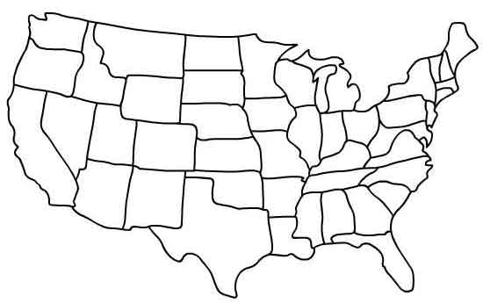Organise the statements into political, social, economic and environmental effects and responses.

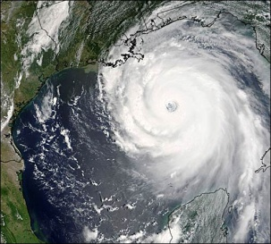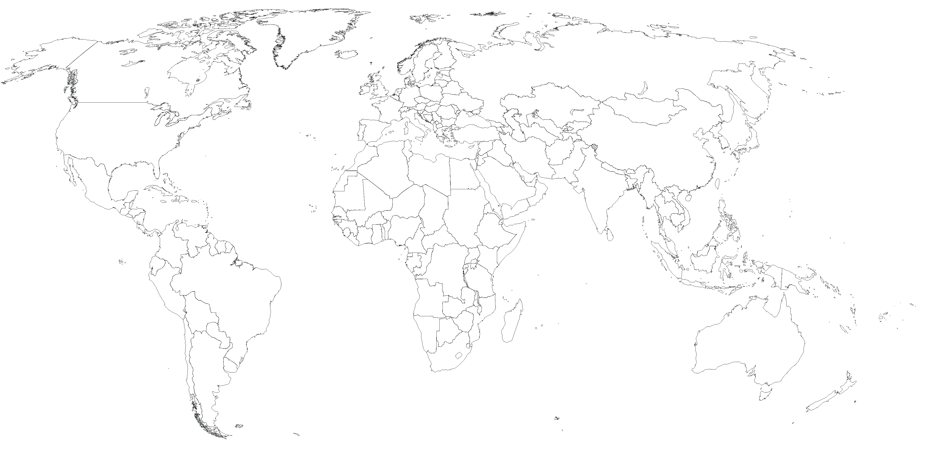

Environmental.

**Wider impacts.**

**Title.**

**Map 2.**

**Key.**

Political.

Social.

Economic.

**Title.**

**Map 1.**

