Economics Article Review Assignment
Each review should be between 1.5-2 pages in length, typed, double-spaced and in 12 font. Make sure to indicate the title of the article you are reviewing.
Read the article carefully and follow each of the steps below:
- Paragraph #1 – summarize the main argument(s) of the article; don’t paraphrase, summarize concisely.

- Paragraph #2- connect the article to economic concepts discussed in class such as supply and demand, the role of the government, inflation, specialization, taxes and subsides etc.. Make sure to link the article to at least 2-3 economic concepts; also make sure to thoroughly explain the connections.

- Paragraph #3- a critical discussion of 2-3 key issues raised in the article. This section is the core of your review. You need to make clear the author's own argument before you criticise and evaluate it. Also you must support your criticisms with evidence from the text or from other writings. You may also want to indicate gaps in the author's treatment of a topic; but it is seldom useful to criticise a writer for not doing something they never intended to do.

- Paragraph # 4 Suggest an issue for further investigation related to the article; in other words, what issue would be worth exploring further? For example, regarding an article on the social costs of smoking you might suggest what could be done to alleviate these costs.
Checklist before you submit your article to be marked
- Have you identified the article clearly, right at the start?
- Is the author's argument clearly and objectively summarised so that your reader can recognise the theoretical approach and the range of material covered? (About a third of a short review.)
- Are the 2-3 key issues raised in this article clearly identified and discussed?
- Have you given reasons for your criticism and your approval of the article?
- Is there a final evaluation of the article's importance, based on your earlier discussion?

Evaluation: each article review will be marked out of 20.

- If referring to words or sentences in the article make sure to use quotation marks.
“................................................”

SCROLL THROUGH THE FOLLOWING PAGES FOR EXAMPLES

Article Review Assignment
Paragraph 1 | This article, ________ written by _________ .  The author presents ________________  The authors argues _________________  The author believes _________________  My overall impression is that the author __________________
Paragraph 2 | In this article, the author contends that ______________________ would find this article useful for studying _________________ .  The argument presented is an example of _________________________. Because __________  This article is useful for _____________ as it shows _________________
Paragraph 3 | The author has been able to ________________ (focus on a trend he has identified or any data he has analyzed)  Economist such as _________ and _________ are also proponents of this view, they agree that ____________  Based on the evidence it is clear that ______________________ (be supportive or critical of his argument)
Paragraph 4 | The author has failed to take into consideration _______________________  Further study on ____________________ would be useful because ________________  In summary, I believe that

Economics Article Review Rubric
Criteria | Does not meet expectations 1 | Barely meets expectations 2 | Fully meets expectations 3 | Exceeds expectations 4
Identifying author’s argument | -an attempt is made to address author’s argument but it is not accurate, or does not represent the author’s argument | - review addresses author’s argument but it may be somewhat unclear, or require further explanation | - review clearly identifies the author’s argument | -review very clearly and carefully addresses author’s argument with precision and nuance
Connection to Economic concepts | -an attempt is made to connect the article to political science concepts- but the concepts may not relate to the article | - 1-2 political science concepts clearly relate to the article, although may be require further explanation | - 2 or more political science concepts clearly relate to the article  -explanations are clear | -2 or more political science concepts clearly relate to the article  -explanations are insightful
Identifying weakness in the article | - review makes an attempt to address the weakness, although it does so incorrectly | -review addresses a weakness in the article, although further explanation may be required | -review clearly addresses a weakness in the article and provides a clear explanation | -review clearly addresses a weakness in the article and provides insightful analysis
Suggestions for further investigation | - an attempt is made to suggest an issue for further investigation, although this issue may not relate to the article | - review suggests an issue for further investigation, more explanation may be required  -issue relates to the article | - review clearly suggests an issue for further investigation  - explanations are clear  -issue clearly relates to the article | -Review very clearly suggests an issue for further investigation  - issue very clearly relates to the article  - insightful analysis provided
Mechanics and grammar | - Numerous grammatical and syntax errors throughout  -meaning is impeded | -while there are a number of grammatical and syntax errors, meaning is generally not impeded | - written expression is generally clear  -there are a few grammatical and syntax errors | - expression is near fluent with minor grammatical and or syntax errors

A third industrial revolution

As manufacturing goes digital, it will change out of all recognition, says Paul Markillie. And some of the business of making things will return to rich countries
Apr 21st 2012 |From the print edition

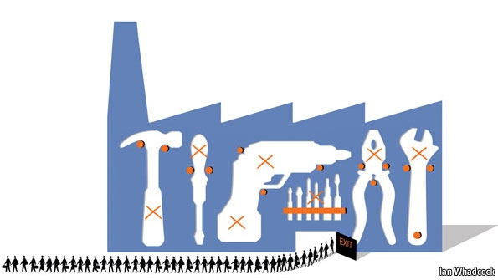
OUTSIDE THE SPRAWLING Frankfurt Messe, home of innumerable German trade fairs, stands the “Hammering Man”, a 21-metre kinetic statue that steadily raises and lowers its arm to bash a piece of metal with a hammer. Jonathan Borofsky, the artist who built it, says it is a celebration of the worker using his mind and hands to create the world we live in. That is a familiar story. But now the tools are changing in a number of remarkable ways that will transform the future of manufacturing.
One of those big trade fairs held in Frankfurt is EuroMold, which shows machines for making prototypes of products, the tools needed to put those things into production and all manner of other manufacturing kit. Old-school engineers worked with lathes, drills, stamping presses and moulding machines. These still exist, but EuroMold exhibits no oily machinery tended by men in overalls. Hall after hall is full of squeaky-clean American, Asian and European machine tools, all highly automated. Most of their operators, men and women, sit in front of computer screens. Nowhere will you find a hammer.
Special report
And at the most recent EuroMold fair, last November, another group of machines was on display: three-dimensional (3D) printers. Instead of bashing, bending and cutting material the way it always has been, 3D printers build things by depositing material, layer by layer. That is why the process is more properly described as additive manufacturing. An American firm, 3D Systems, used one of its 3D printers to print a hammer for your correspondent, complete with a natty wood-effect handle and a metallised head.
This is what manufacturing will be like in the future. Ask a factory today to make you a single hammer to your own design and you will be presented with a bill for thousands of dollars. The makers would have to produce a mould, cast the head, machine it to a suitable finish, turn a wooden handle and then assemble the parts. To do that for one hammer would be prohibitively expensive. If you are producing thousands of hammers, each one of them will be much cheaper, thanks to economies of scale. For a 3D printer, though, economies of scale matter much less. Its software can be endlessly tweaked and it can make just about anything. The cost of setting up the machine is the same whether it makes one thing or as many things as can fit inside the machine; like a two-dimensional office printer that pushes out one letter or many different ones until the ink cartridge and paper need replacing, it will keep going, at about the same cost for each item.
Additive manufacturing is not yet good enough to make a car or an iPhone, but it is already being used to make specialist parts for cars and customised covers for iPhones. Although it is still a relatively young technology, most people probably already own something that was made with the help of a 3D printer. It might be a pair of shoes, printed in solid form as a design prototype before being produced in bulk. It could be a hearing aid, individually tailored to the shape of the user's ear. Or it could be a piece of jewellery, cast from a mould made by a 3D printer or produced directly using a growing number of printable materials.
But additive manufacturing is only one of a number of breakthroughs leading to the factory of the future, and conventional production equipment is becoming smarter and more flexible, too. Volkswagen has a new production strategy called Modularer Querbaukasten, or MQB. By standardising the parameters of certain components, such as the mounting points of engines, the German carmaker hopes to be able to produce all its models on the same production line. The process is being introduced this year, but will gather pace as new models are launched over the next decade. Eventually it should allow its factories in America, Europe and China to produce locally whatever vehicle each market requires.

They don't make them like that any more
Factories are becoming vastly more efficient, thanks to automated milling machines that can swap their own tools, cut in multiple directions and “feel” if something is going wrong, together with robots equipped with vision and other sensing systems. Nissan's British factory in Sunderland, opened in 1986, is now one of the most productive in Europe. In 1999 it built 271,157 cars with 4,594 people. Last year it made 480,485 vehicles—more than any other car factory in Britain, ever—with just 5,462 people.
“You can't make some of this modern stuff using old manual tools,” says Colin Smith, director of engineering and technology for Rolls-Royce, a British company that makes jet engines and other power systems. “The days of huge factories full of lots of people are not there any more.”
As the number of people directly employed in making things declines, the cost of labour as a proportion of the total cost of production will diminish too. This will encourage makers to move some of the work back to rich countries, not least because new manufacturing techniques make it cheaper and faster to respond to changing local tastes.
The materials being used to make things are changing as well. Carbon-fibre composites, for instance, are replacing steel and aluminium in products ranging from mountain bikes to airliners. And sometimes it will not be machines doing the making, but micro-organisms that have been genetically engineered for the task.
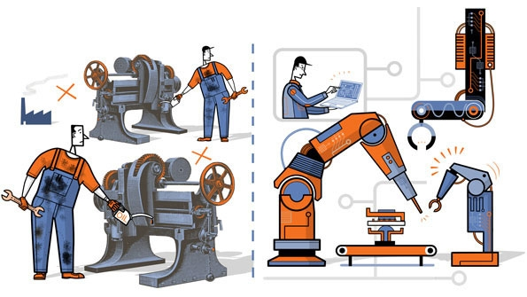
Everything in the factories of the future will be run by smarter software. Digitisation in manufacturing will have a disruptive effect every bit as big as in other industries that have gone digital, such as office equipment, telecoms, photography, music, publishing and films. And the effects will not be confined to large manufacturers; indeed, they will need to watch out because much of what is coming will empower small and medium-sized firms and individual entrepreneurs. Launching novel products will become easier and cheaper. Communities offering 3D printing and other production services that are a bit like Facebook are already forming online—a new phenomenon which might be called social manufacturing.
The consequences of all these changes, this report will argue, amount to a third industrial revolution. The first began in Britain in the late 18th century with the mechanisation of the textile industry. In the following decades the use of machines to make things, instead of crafting them by hand, spread around the world. The second industrial revolution began in America in the early 20th century with the assembly line, which ushered in the era of mass production.
As manufacturing goes digital, a third great change is now gathering pace. It will allow things to be made economically in much smaller numbers, more flexibly and with a much lower input of labour, thanks to new materials, completely new processes such as 3D printing, easy-to-use robots and new collaborative manufacturing services available online. The wheel is almost coming full circle, turning away from mass manufacturing and towards much more individualised production. And that in turn could bring some of the jobs back to rich countries that long ago lost them to the emerging world.

Article Review Assignment
Paragraph 1 | Markville argues that:  - Changes in the digitization of manufacturing (3D printers, automated milling machines, smart software) will have the following effects”  - economies of scale will not matter as much with 3D printer technology  - the cost of labour as a proportion of the total cost of production will decrease  - this will encourage manufacturers to move back to developed countries  - it will be easier for small and medium sized companies to expand due to new manufacturing methods  - These changes are akin to a third industrial revolution.
Paragraph 2 | In this article, the author contends that ______________________ would find this article useful for studying:  - Economies of Scale.  - The factors of production.  - The price mechanism.  - Supply and demand of labour
Paragraph 3 | Economies of Scale  Makes the point that due to economies of scale these days firms have to produce in bulk in order to make a profit. (Technical Economies) New technology would allow a firm producing hammers to make individual ones at a low cost, which would be very time consuming and expensive today. Nissan has able to massively increase output  Factors of production.  The importance of labour will diminish in the production process, therefore reducing costs. (E.g. Nissan in Sunderland)  The price mechanism.  Firms will be encouraged to move operations back to developed countries, as new manufacturing techniques make it cheaper and faster to respond to local tastes.  Jeremy Rifkin, is also a proponent of this view, wrote a book on the subject.
Paragraph 4 | Markville did not take into consideration the social costs of this change:  - If less labour is required then less workers are required too – what will be the effects of this.  - How will labour unions react? The government?  - What is going to power this revolution? Coal, Oil, Renewable Energy?

