**Read pp.4 to 6 from the digital textbook and add to the spider diagram below:**

**Factors of Production**

the resources we have available to produce goods and services.

**LAND**

**LABOUR**

**CAPITAL**

**ENTERPRISE**

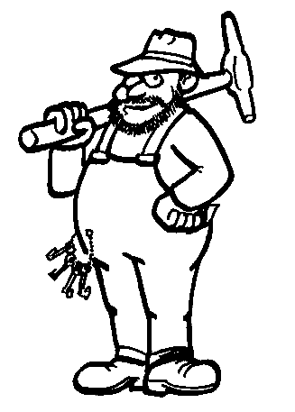**Labour**

Labour is the **human input** into the production process.

Which of the following would be an example of labour at your school?

* Computer
* Teacher
* Vacuum cleaner
* Desk

Not all labour are of the same quality. Every person has different skills, qualities and qualification. We call this **human capital**

Think about your **human capital**. Make a list of your skills, qualities and qualifications.

_____________________________________________________________________________________________________________________________________________________________________________________________

MCj03042990000[1]How does your **human capital** differ from your teachers’? Is there a difference between the **human capital** of a cleaner and a doctor?

*Discuss in pairs and write down a few ideas. You have 5 minutes for this task.*

_____________________________________________________________________________________________________________________________________________________________________________________________

When people have more human capital they are likely to be more **productive**.

**Productivity –** output per person per period of time.

**Example** – Toby is a table maker. He has been working as a table maker for 2 weeks. He has been making 5 tables a day since he started. We can therefore say his productivity is 5 tables per day. Toby’s boss decides that he needs to do some more training, so asks him to take study a qualification in table making. After taking this qualification Toby is able to make 8 tables a day. His productivity has increased. His human capital has also increased.

MCj03839520000[1]

**Capital**

The term capital means **investment in goods that are used to produce other goods in the future**.

Examples include machinery, plant and equipment, new technology, factories and buildings.

At school your teachers are producing a service. They use **capital** to help them provide the service of education. List some items used in school that are capital.

__________________________________________________________________________________________________________________________________________________________________________________________________________________________________________________________________________________________________________________________________________________________________________________________

MCj03042990000[1]

How do we make capital more productive?

*Discuss in pairs and write down a few ideas. You have 5 minutes for this task.*

**1. Set clear financial objectives:** targets should be attainable but challenging. Every decision should contribute directly to achieving these goals.

**2. Align your risk appetite, profile, and tolerance with your goals:** the assumption of risk should be consistent with your stated financial objectives. If you have lofty ambitions but a [low tolerance for risk](http://www.gccapitalideas.com/2009/04/30/risk-profile-appetite-and-tolerance-fundamental-concepts-in-risk-management-and-reinsurance-effectiveness/), for example, at least one side of the equation has to change.

**3. Understand the threats to your capital:** identify the risks that you face — including[those that may be hidden](http://www.gccapitalideas.com/2009/05/04/casualty-cat-part-i-casualty-catastrophe-risk-modeling/). Model the scenarios to see the potential outcomes — positive and negative.

**4. Evaluate your alternatives:** using [model output](http://www.gccapitalideas.com/tag/modeling) and [risk manager judgment](http://www.gccapitalideas.com/tag/risk-management), compare strategies and choose the best option based on your financial objectives. Take informed action.

**5. Measure the results:**revisit this process regularly. Market conditions change … and so does your portfolio.

_____________________________________________________________________________________________________________________________________________________________________________________________

________________________________________________________________

**Land**

Land is the **natural resources** available for production.

Some nations have a large amount of a particular natural resource and so are able to specialise in the **extraction** and production of it – for example – the development of the Oil Wells in parts of the Middle East.

Which of the following is **land**?

* Farmland where crops are grown.
* Factory
* Computer
* Factory worker

**Enterprise**



**Enterprise** is the idea of ‘taking risks’ in setting up or running a business.

An **‘entrepreneur’** is someone who takes those risks, perhaps someone who puts in their money or has the ideas and the drive to set up or run the business.

Which of these people take risks that might be thought of as ‘Enterprise’ in a business?

* Customers
* Staff
* Shareholders (owners)
* Senior management

MCj03042990000[1]

In which of these occupations might you find entrepreneurs? For each one, give an example of a person who you think might be called an entrepreneur.

* Plumbing
* Carpet making
* Car manufacturing
* Building
* Restaurant

*Discuss in pairs and write down a few ideas. You have 5 minutes for this task.*

_____________________________________________________________________________________________________________________________________________________________________________________________

In Economics, the profits that a business makes go to *the risk takers* i.e. the entrepreneurs.

**The reward for enterprise (risk) is profit.**

Draw three columns and classify the following resources

