How consumers’ decisions can affect others
So far we have only considered how firms’ decisions to produce goods and services can affect society as a whole. We will now look at how people’s decisions to consume goods and services can affect others. Consider the following examples:
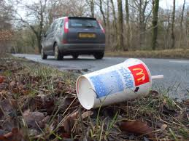
The person who bought this drink from McDonalds has discarded it on the side of the road, rather than placing it in the garbage. Litter is unsightly to many people. This is an external cost resulting from other’s consumption. Furthermore, society must bear the cost of cleaning up the rubbish.

The girl in the picture likes playing the drums very loudly. Explain what the external cost of this could be and to whom.
___________________________________________
___________________________________________
___________________________________________
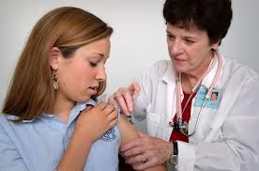
The girl in the picture is going on vacation to Kenya and must get some vaccinations before she travels to protect herself from the diseases she may catch in that country. This is a private benefit to her. However, there are also external benefits from this consumer decision. By having the vaccination it protects other people that could have been infected if she brought a disease back to her home country. Her decision to have the vaccination has therefore protected the rest of society.

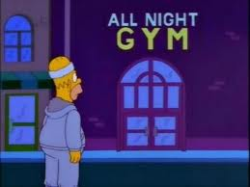
Homer has made the decision to lose weight and get healthy by joining a local gym. Explain how this will be a private benefit to him and can be considered to be an external benefit.
______________________________________________
______________________________________________
_______________________________________________

