How to add animation to items
Google Presentations allows you to add animations to text and images so they will appear or disappear on your slide in a predetermined order. This can be helpful to show just what you want while you are giving your presentation.
- Select any text or object by clicking on it
- Now click “Insert” and then “Animation” to open up the “Animations” panel on the right side of the screen.
- You can choose the type of animation including “Fade in”, “Fade out”, “Fly in”, “Fly out”, “Zoom in”, “Zoom out”, and “Spin”.
- You can choose when the animation occurs by choosing between “On click”, “After previous”, or “With previous”.
- For text you can check the box for “By paragraph” so that the text will animate one paragraph at a time (allowing you to speak about each point before revealing the next).
- You can control the speed of the animation by clicking a slider from “Slow” to “Fast”.
- If you have multiple items animated on one slide, you can drag and drop them in the “Animations” panel to change their order.
- You can click the “Play” button to preview your animations for that slide.

How to change transitions between slides
You can add transition effects between slides to make a more dynamic or creative presentation.
- Click “Slide” then “Change transition” to open the “Animations” side panel.
- At the top of the panel you can pick a transition for the entrance of the current slide (transitions apply to the entrance of a slide, not its exit).
- For transitions you can choose “No transition”, “Fade”, “Slide from right”, “Slide from left”, “Flip”, “Cube”, and “Gallery”.
- You can control the speed of the transition by clicking a slider from “Slow” to “Fast”.
- If you want this transitions for all your slides, click the “Apply to all slides” button.

How to find good images online
There are many excellent resources for finding images online. Here is a list of some good options:
- Google Images (advanced mode) - http://images.google.com/advanced_image_search?hl=en
- Picsearch (advanced mode) - http://www.picsearch.com/index.cgi?st=advanced
- Open Clip Art Library - http://www.openclipart.org/
- Public Domain Clipart - http://www.pdclipart.org/
- WP Clipart - http://www.wpclipart.com/
- Clker.com - http://www.clker.com/
- Hassle Free Clipart - http://www.hasslefreeclipart.com

How to insert a video into a slide
Google Presentations allows you to insert videos into your slides as long as those videos are already online through YouTube.
- Click “Insert” in the top menu bar.
- Then choose “Video...” from the drop-down menu
- You will now get a pop-up window where you can enter your search term.
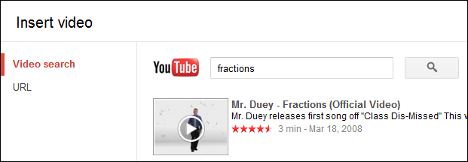
- You can now scroll through the video thumbnail results to find one you would like to insert.
- Click on the video you want and then click “Select”.
- The video will now be placed on your slide.
- You can click and drag the corner handles to resize the video.
- You can click and drag the center of the video to move the video.
- You can delete the video by right-clicking on it and choosing “Cut”.

How to insert Word Art into a slide
You can also insert Word Art to create more creative titles and text.
- Click “Insert” in the top menu bar.
- Then choose “Word Art” from the drop-down menu.
- You can now type in the text you want and press “Enter”
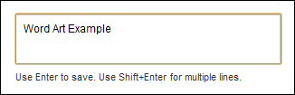
- Once the Word Art has been inserted you can modify it in many ways:

  - You can click and drag the corner handles to resize the Word Art.
  - You can click and drag the center or edge of the item to move the Word Art.
  - You can click and drag the circle handle to rotate the Word Art.
  - You can use the toolbar buttons to change the fill color, line color, line width, and line style.

