Liquidity
Rank the following types of money in order of liquidity, starting with the one that is most liquid. Rank them from the point of view of an individual.
Notes and coins, a bank deposit account (1 week's notice), a building society account (3 month's notice), 1 year building society bond
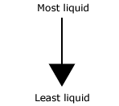
- _______________________________________________
- _______________________________________________
- _______________________________________________
- _______________________________________________
- _______________________________________________
What are the advantages and disadvantages of holding your money in a liquid form?
Advantages

Disadvantages

