This is the reason for the existence of this subject. In reality most resources are scarce. Similarly individuals and nations have unlimited wants.
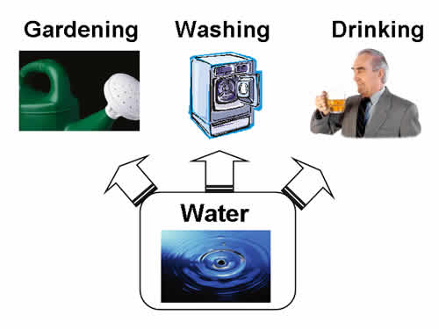
Scare Resources
There are only a limited number of resources such as workers, machines, factories, raw materials etc. Yet there are a number of different ways in which they could be used.
Can you think of some different uses for oil?
______________________________________________________
______________________________________________________
______________________________________________________
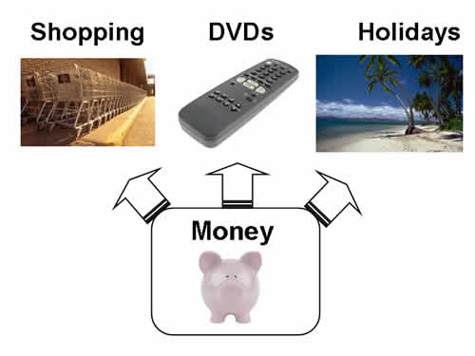
Similarly people only have a limited amount of money. Yet they have lots of needs and wants to satisfy.
List your top three needs and wants:
______________________________________________________
______________________________________________________
______________________________________________________
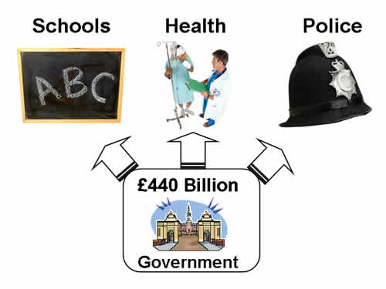
Also the UK Government has a limited amount of money and so therefore is unable to satisfy all its wants.
Which do you feel is the most important? Why?
______________________________________________________
______________________________________________________
______________________________________________________
THE BASIC ECONOMIC PROBLEM – the problem arises because resources are scarce, but human wants are unlimited.
Answer the following question in your notebook in paragraph form
What is the difference between needs and wants?

