Labour as a derived demand
Workers are needed for the output they are required to produce. We say that labour as a factor input is a derived demand. When firms see increasing demand for their products, they will need to employ extra workers and thus the demand for labour increases.
- Demand for labour is said to be ‘derived demand’. What is meant by ‘derived demand’?
______________________________________________________________________________________________________________________________________________________________________________________________________
Demand for labour and the market wage rate
There is normally an inverse relationship between the demand for labour and the wage rate that the firm will have to pay for each additional worker. If wages are high, it is more costly to hire extra employees. When wages are lower, labour becomes more attractive and affordable for the business to take on more employees.
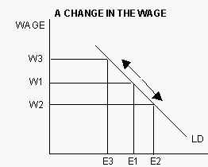
In the diagram, when there is a fall in the wage rate from W1 to W2, the firm will expand employment from E1 to E2. This is because the labour has become cheaper, a rise in the wage rate from W1 to W3 causes a contraction of labour demand.
- Explain the relationship between labour demand and wages. Is it positive or inverse?

______________________________________
______________________________________
______________________________________ ______________________________________
______________________________________ ______________________________________

Defining the labour supply
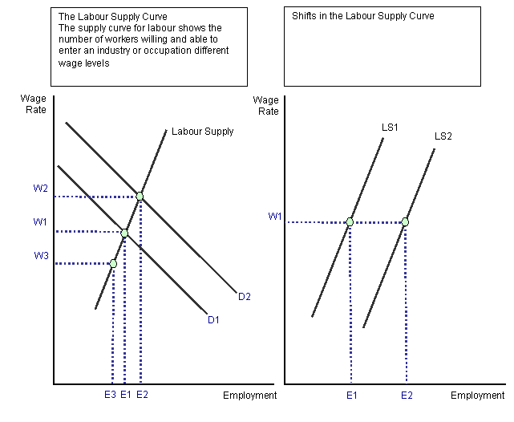
The labour supply refers to the total number of hours that labour is willing and able to supply at a given wage rate. It can also be defined as the number of workers willing and able to work in a given occupation or industry for a given wage.

What could cause a shift in the labour demand curve?
______________________________________________________________________________________________________________________________________________________________________________________________________
What could cause a shift in the labour supply curve?
______________________________________________________________________________________________________________________________________________________________________________________________________

Review activity: In the table below, complete the following:
- Record the affect on supply of each of the four determinants.
- In each instance, state if the supply curve shifts right or left.
- In your own words provide an explanation of the suppliers’ reactions.

Determinant of supply |  | Affect on supply | Explanation
A change in the price of inputs (raw materials, wages, etc.) | A decrease in the price of inputs.
 | An increase in the price of inputs.
A change in the number of firms in the industry. | Increase in the number of firms in the industry
 | Decrease in the number of firms
A change in taxes | Increase in taxes
 | Decrease in taxes
Technology development

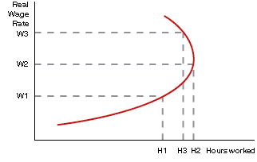
So, we have seen that generally there is an inverse relationship between the demand for labour and the wage rate, and a positive relationship between labour supply and wages. However, it may not always be the case that an individual will be willing to work more hours as the wage rate rises. At some point though our worker may choose to take a rest and enjoy his or her leisure time.
As wages increase above a certain point less work will actually be done as work is an inferior good and leisure becomes more highly valued to the worker. (BTW: in this case we have assumed that leisure is considered to be more desirable that working.) This causes the supply curve to bend backwards. The opportunity cost involved in working - forgone hours of leisure - give a backward bending supply of labour curve for the individual.

In your own words, explain why the labour supply curve us bending backwards.
______________________________________________________________________________________________________________________________________________________________________________________________________
Explain three things other than wages that would affect your choice of an occupation.
______________________________________________________________________________________________________________________________________________________________________________________________________ ____________________________________________________________________________________________________________________________________________________________________________________________________________________________________________________________________________________________________________________________________________________________________________________________________________

