For each of the images below suggest reasons why a government might impose taxes.
What impacts could such taxes have?
_________________________________
_________________________________
_________________________________
_________________________________
_________________________________
_________________________________
_________________________________

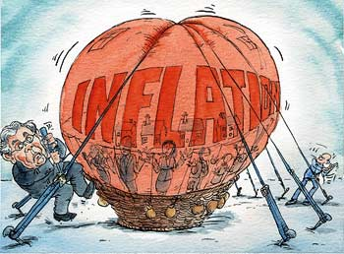 | _________________________________  _________________________________  _________________________________  _________________________________  _________________________________
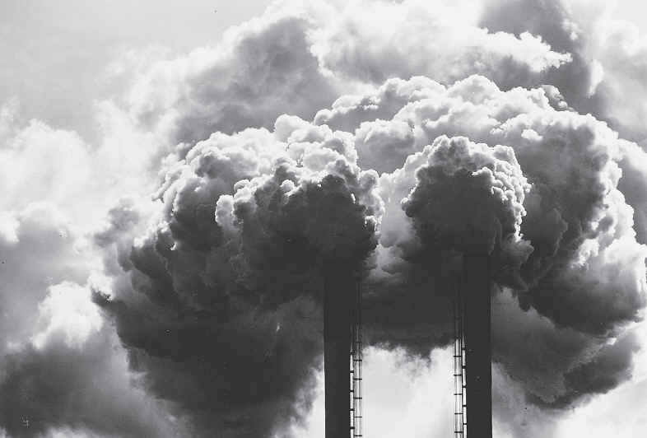 | _________________________________  _________________________________  _________________________________  _________________________________  _________________________________  _________________________________  _________________________________
Rich-Poor Gap / Inequality  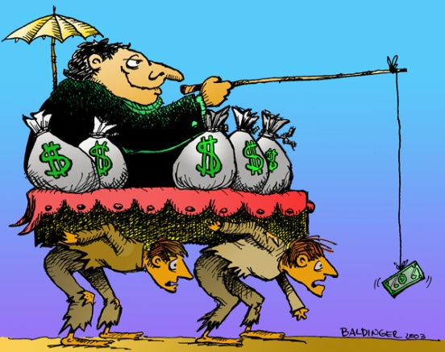 | _________________________________  _________________________________  _________________________________  _________________________________  _________________________________  _________________________________  _________________________________
Activity 5.6 Why have taxes?
Image 1: The government might impose taxes to finance public expenditure, for example for the provision of a police service.
Image 2 : Taxes might be imposed to help control aggregate demand, for example, by raising the overall level of taxation to reduce inflationary pressures
Image 3 : The government might want to influence the behaviours of consumers and producers, for example to reduce pollution by taxing petrol and vehicles that produce significant emissions more heavily than other vehicles or forms of transport, to encourage consumers to switch their consumption.
Image 4 : The aim might be to reduce inequalities in incomes by taxing high incomes proportionally more than low incomes.

